IVCA-Dick O Brien Leisure League 2020 Round 3 - 8th March 50 in 4.
The 3rd Round of the Dick O'Brien Leisure League was scheduled from the 8th March with sign on at commencing at 8:40 for a 9:00 start.

A total of 5 riders signed on which was somewhat disappointing given that this event would attract figures closer to 20. Before setting out the group were issued with a route map and reminded of the safety rules and road conditions.

The group remembered Gay Farnan, our touring director who passed away in March 2017 and were mindful of how he always welcomed members and encouraged involvement through his quite leadership style.

With this in mind the group set out in the direction of Dunboyne and on towards Summerhill at a steady pace with some rotation on the front allowing the weaker riders to sit on the back.

On the approach to Summerhill the group turned right, proceeded passed the church and commenced the gradual climb to the Trim Roundabout with one of our riders dropping off and taking a left turn towards the return route to Summerhill. As we approached the Knightsbrook Roundabout the remaining riders were in tight formation and rounded the bend into a strong headwind. 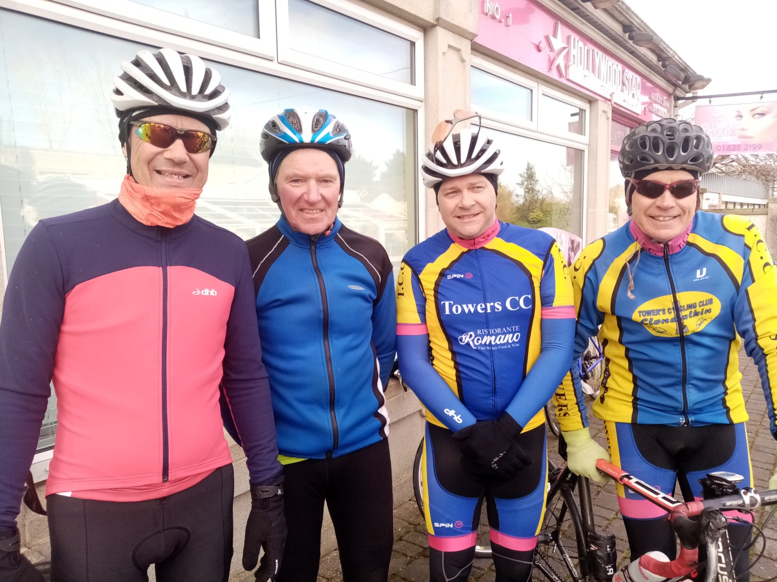
Jimmy Murphy and yours truly rotated to the front and lead the group as it made its way from Knightsbrook to Mayne and turned back in the direction of Summerhill. As we approached Summerhill the group stayed together unlike other years when we had a competitive sprint finish. The group stopped in Summerhill for a well-earned tea break at the cycle friendly Londis Store where we met up with Seamus Brennan who took an alternative route to the tea stop.
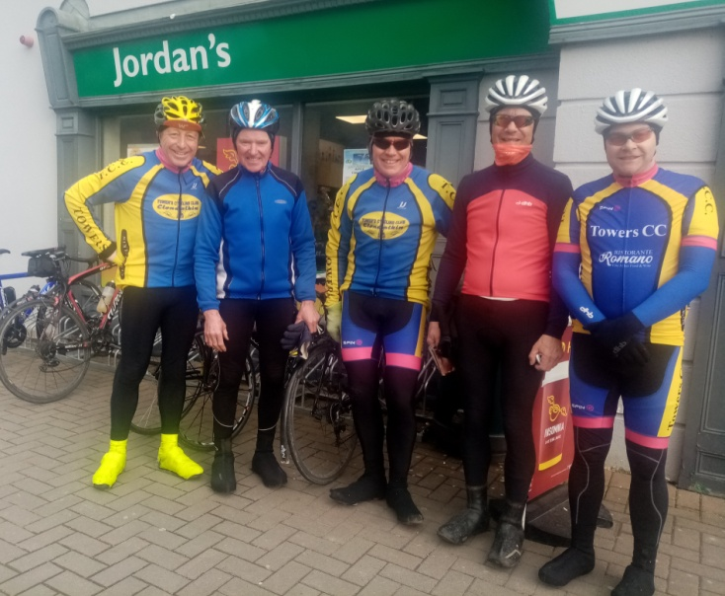
This gave riders a chance to reflect on the tour and the assess changing weather conditions.
After some banter and photos, the group decided to make their way back in the direction of Summerhill. Just as we departed from Summerhill the heavens opened and riders individually took time to stop and put on their rain jackets. As the rain eased off the group reformed making sure no one was left behind.

We proceed towards the finish in Colnee at a steady pace . The temperature was dropping, and riders were feeling the cold, notwithstanding this a good day was had by all with no mechanicals or punctures.

The next tour is the Liam Horner Memorial and was scheduled for the 5th April at 10:00am starting in Clonee, unfortunately due to COVID 19 the event has been postponed (kindly check the IVCA web site to confirm details the next event)
Tony Pearson.

