IVCA Leisure League Round 1
East Kildare Tour
12/01/20

I put the route of this tour together about seven years ago when Gay Farnan, our late Tour Director, asked some of us in the leisure group to take on the duties of organising leisure league tours. There have been a few variations over the years, but I think everyone enjoys this particular circuit.
We had 9 riders signing-on at Wheelworx, consisting of 8 IVCA members and 1 guest. Weather conditions were near perfect for the time of year with clear blue skies and mostly dry roads.
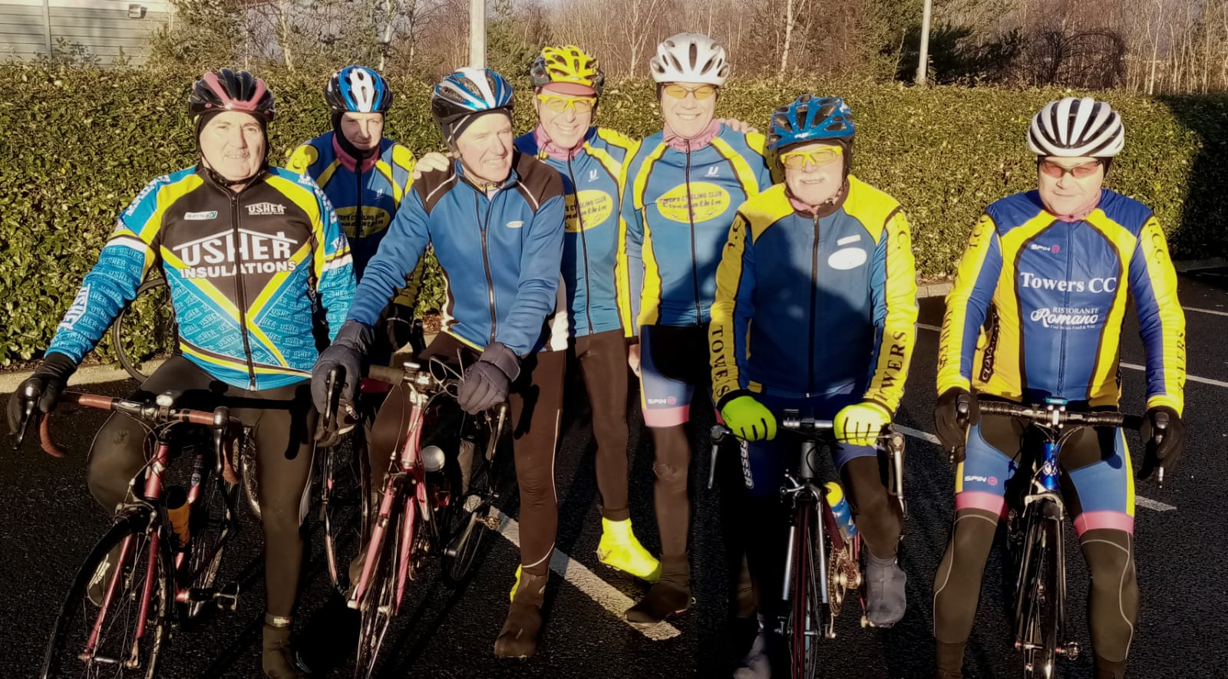
Group ready to depart Wheelworx

Tony Pearson, who has agreed to take on the running of Leisure League for 2020 thanked Evelyn Doyle for her very successful running of the 2019 League. Following a brief chat about the route, safety notes, planned tea stop, etc. we headed off.
After approx. 2km, we came across an IVCA member (who shall remain nameless) wandering around the outskirts of Clondalkin. He apparently had no idea where the tour started, and it was by a sheer stroke of luck that we found him!!! This brought our numbers to a nice even number of 10 with everyone having a cycling buddy to chat with!!
The tour brought us through Baldonnel, Newcastle, Ardclough, Straffan, and up and over the climb before dropping down into Sallins. We had a good rotation of riders at the front with most taking a turn.
From Sallins we were briefly on the main road to Clane before turning onto the quieter Millicent Road, where we kept the group together through several leg testing drags.
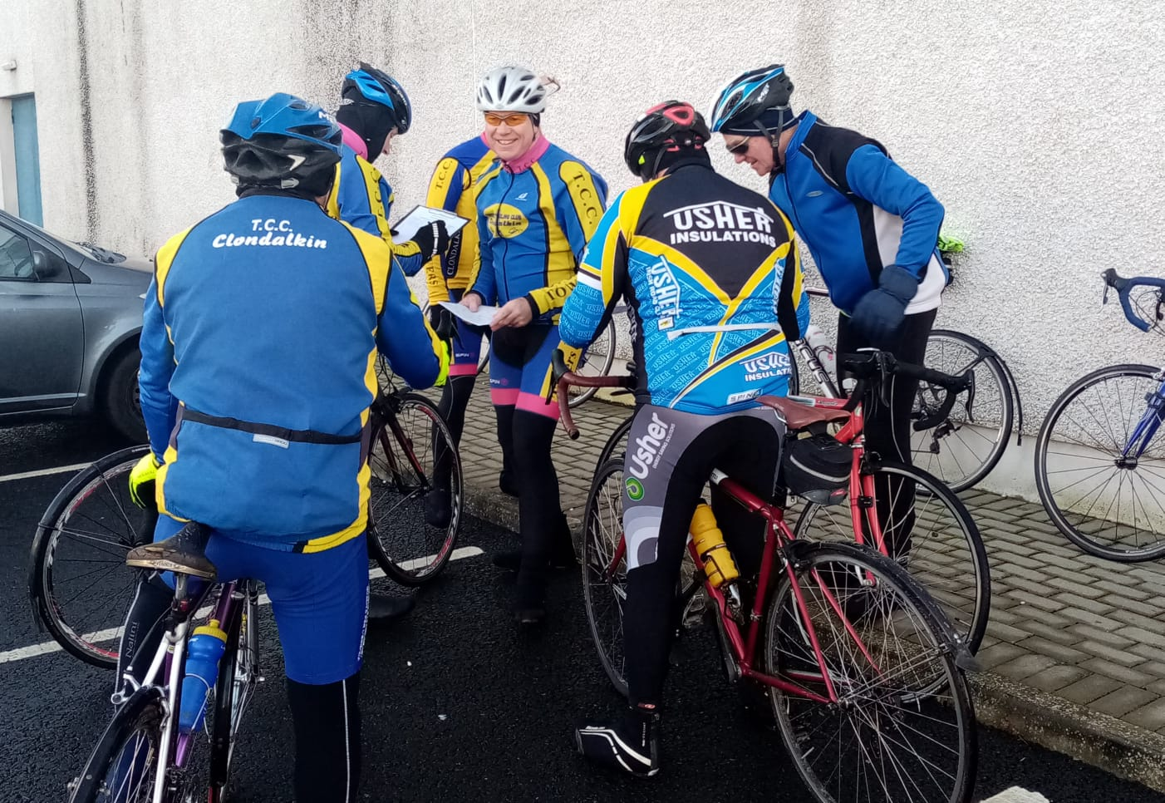
Sign-on
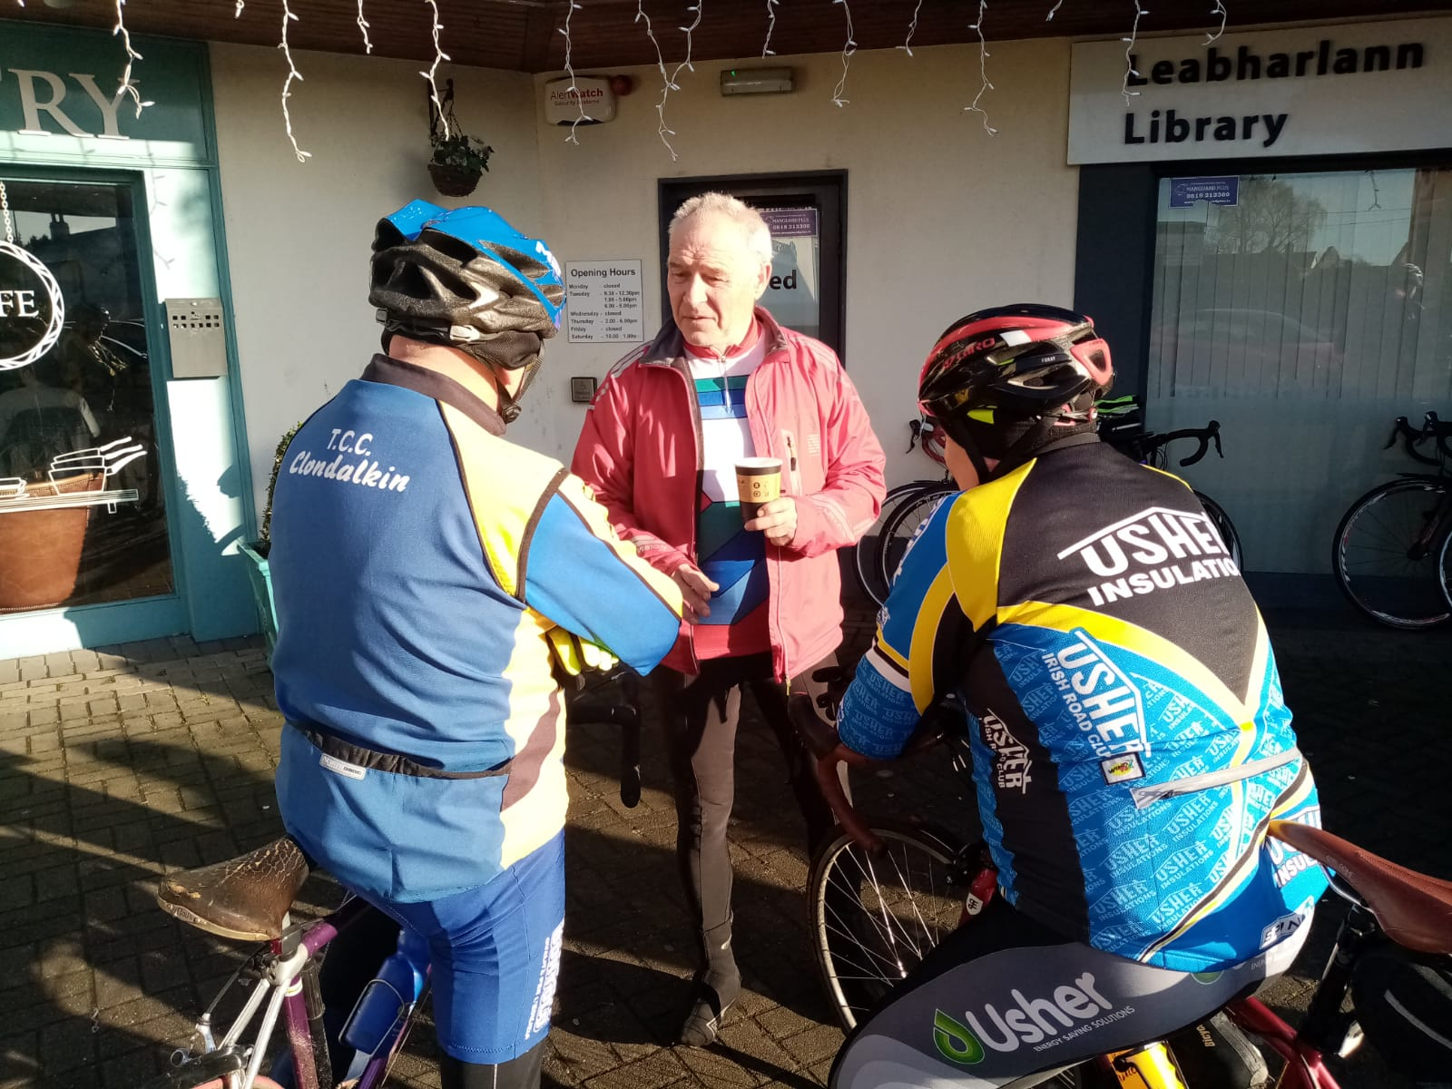
Tea Stop in Clane
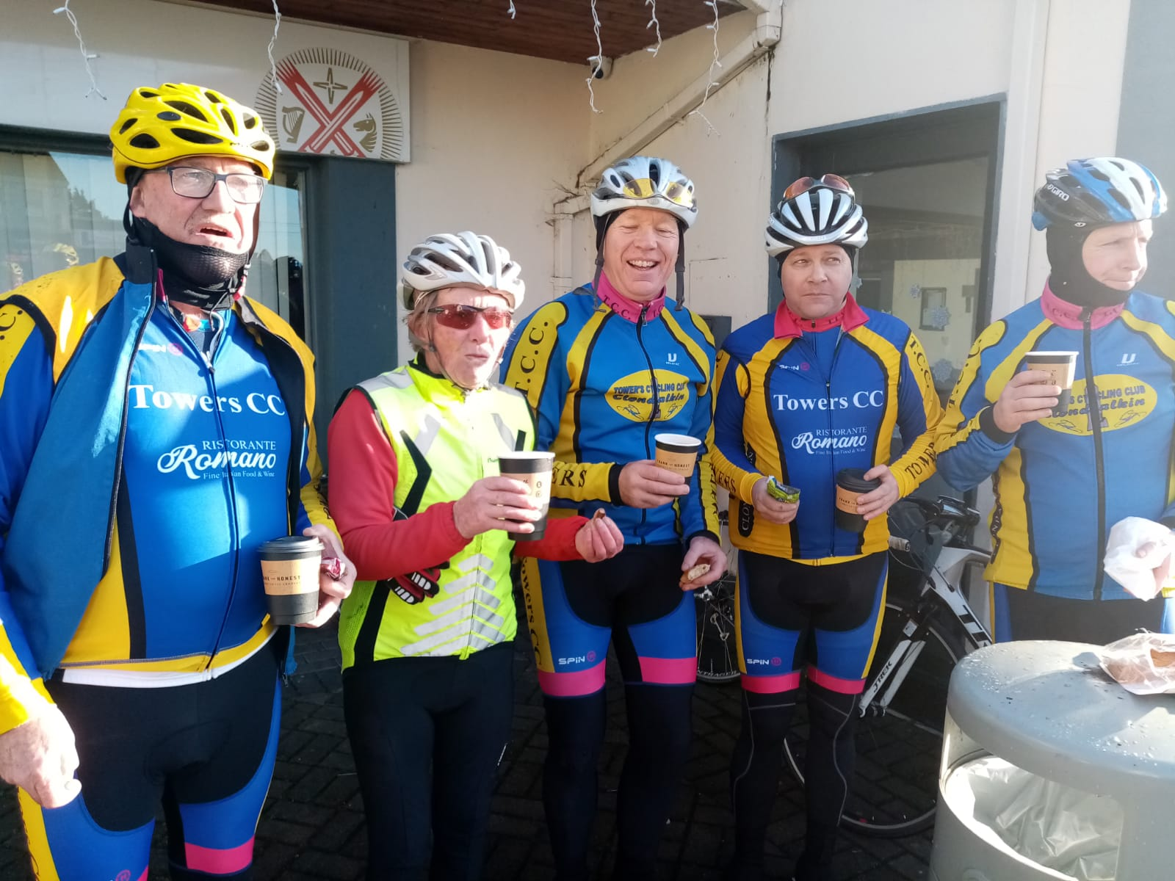
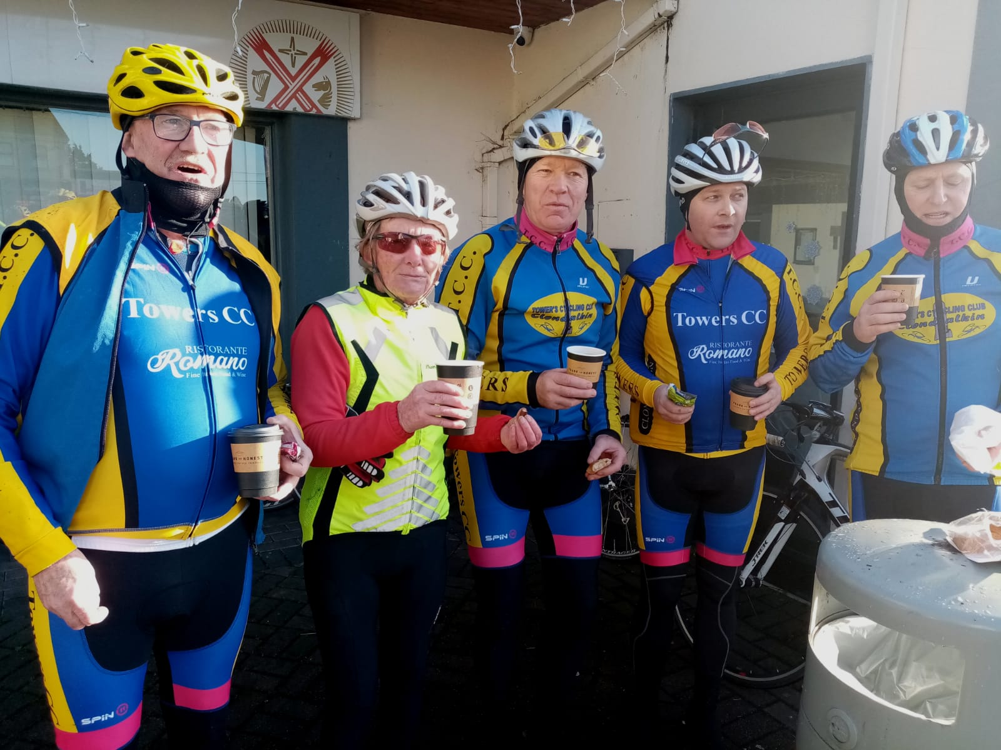
Tea Stop in Clane
Very soon, we turned right at the junction with Prosperous Road and descended rapidly to Clane where a much needed tea stop was enjoyed by all. Following a few more photos, we set off again in the direction of Rathcoffey, Ladychapel, and into Maynooth where we encountered the heaviest traffic of the day.
From Maynooth we headed towards Celbridge, Hazelhatch and past Peamount Hospital. From there it was mostly downhill towards Adamstown and from there, following the Bus Lane we arrived back at Wheelworx safe and sound.

The total distance was 73km and 2 leisure league points are awarded to each member.
Photos, thanks to Tony Pearson.
The next round of the leisure league will be the North Dublin Tour 75km, on Feb 9th departing from Airside Retail Park, Swords at 10am (To be confirmed, check website for details).

Jimmy Murphy

