The 9th round of the Dick O Brien Leisure League commenced for the first time at Cycle Superstore on Airton Road Talaght, with a start time of 9:00 am. The weather forecast was for dry weather with temperatures rising from 15 to 19 degrees.
A total of 7 IVCA riders signed on for this challenging event. The route planned took account and incorporated the route set by our late touring Director of the Leisure League Gay Farnan ,(left) who had successfully organised this event with large numbers of riders participating for many years.
As the temperatures starting off were crisp there was no time for hanging about. After a short briefing outlining the route and conditions the group set out with two experienced riders setting out first at fast pace.
The route ahead would consist of rolling roads with some nice hills just to get the heart rate going with a planned tea stop in Dunlavin.
The remaining members set out at a steady pace in the direction of Belgard Road and the Embankment. As the group completed the assent to the Embankment they took a right turn to Saggart, the pace remained constant to ensure the group stayed together. The temperatures were beginning to rise, the clouds began to clear and everyone was in good spirits.
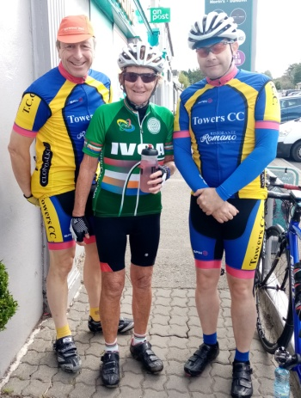
The group proceeded to Saggart and on through Rathcoole where we took on the first climb of the day (Windmill Hill). The first riders to reach the top waited for a while and then proceeded to take advantage of the well earned decent and onto Kill. As we proceeded to Punchestown we took advantage of enjoyable views of the Eadestown Field Event which shows Kildare in a different light.
Our next destination points included Mullincash and then left at the 'T' junction in the direction of Kilcullen and through Brackenstown and on to Dunlavin for a well earned Tea Stop and time for a traditional photo.
Feeling in good spirits we set out for the second leg of the tour which would prove to be enjoyable as the sun was shining and temperatures where rising.
As we set out from Dunlavin we took the road in the direction of Hollywood and the next left to Ballymore Eustace with rolling roads. It wasn't long before we arrived at the N81 and on to Blessington stopping for a short time after taking in breath taking views of the Blessington Lakes and the Poulaphouca Reservoir.
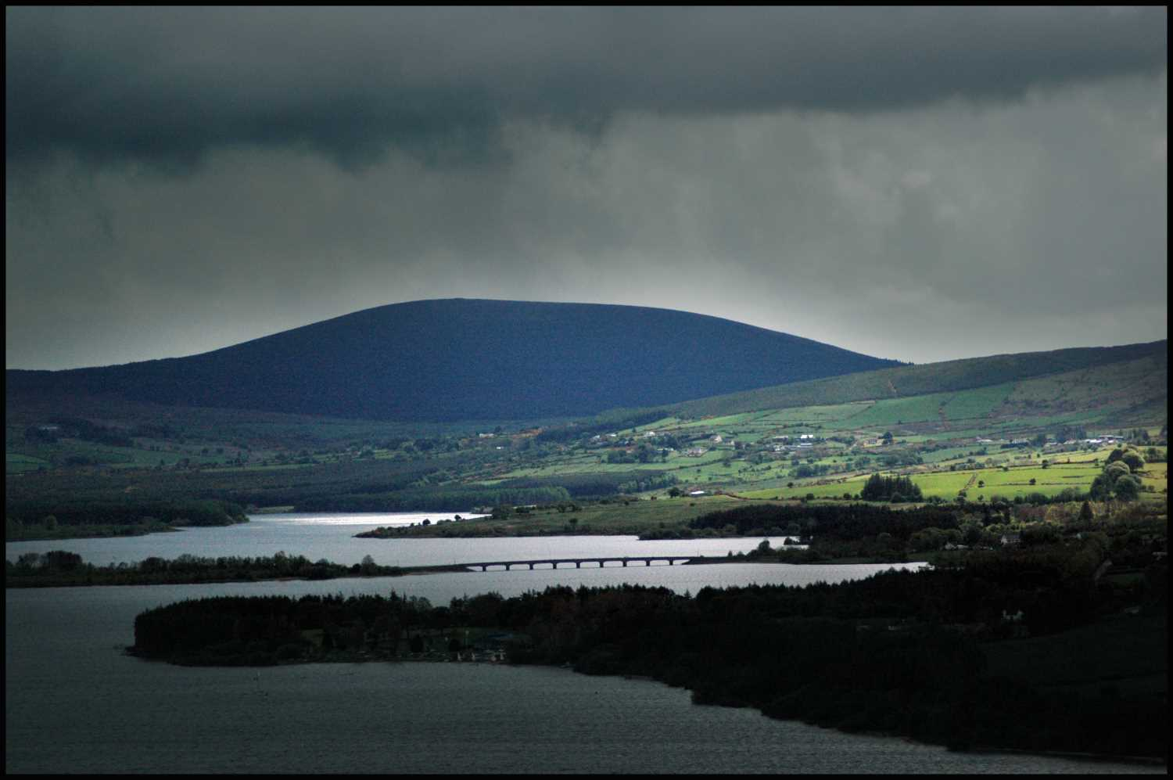
Proceeding from Blessington the group singled out staying safely together heading in the direction of Brittas and on to the start of our final fast decent. All riders approach the decent with safety in mind and commenced the decent with a time gap between each rider making our way to the finish at Airton Road.
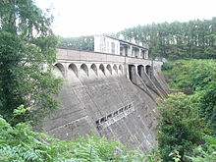

With no punctures or mechanicals all riders finished safely and in good spirits. The next events for your diary are the Joe Hoare Memorial starting in Clonee at 9:00am on the 6th October and the Gay Farnan Memorial on the 20th October starting at 10:00am in Dunsany GAA Club. Just to remind everyone that Gay Farnan was an IVCA Board Member, Director of the Leisure League and Chairman of the Wicklow 200 for many years, hope to see all IVCA members and fellow cyclists/clubs at the Gay Farnan Memorial which has proven to be a most enjoyable event, please check the website for details.
Tony Pearson
