The 5th round of the Dick O Brien Leisure League commenced for the fourth year at Cycle Superstore on Airton Road Talaght, with a start time of 9:00 am. The weather forecast was for dry weather with temperatures rising to 15 degrees.
A total of 7 IVCA riders signed on for this challenging event. The route planned was ideal preparation for those taking part in the Wicklow 200 next month which proves again to be an exceptional challenge given the location of the start point and early climbs.
As the group were anxious to get started the rout was stated which for the early part of the tour would be scenic with breathtaking views of the lower lakes and a planned tea stop in Laragh.
As we proceeded up the road members remembered Gay Farnan,(left) Director of the Leisure League who passed away on the 29th March 2017. Gay initiated and set this route some years ago with a start point in the Square Tallaght to help prepare tour riders for the Wicklow 200 in which he played no small part in organising.
The group set out at a steady pace in the direction of the Belgard Road and Blessington. As the group commenced the assent up the Blessington Road to Brittas the pace remained constant to ensure the group stayed together. The weather looked promising and everyone was in good spirits.
The group proceeded through Brittas and took the left turn in the direction of Manor Kilbride away from the main traffic and on to the lower lakes, as we made our way towards Blessington the sun was shining brightly on the lakes and the views were breathtaking.
From Blessington we made our way onto the N81 in the direction of Poulaphouca where we encountered a Garda check point before taking in more stunning lake views and continuing to Hollywood where we stopped and took on few supplies before commencing the first climb of the day.
The climb from Hollywood got the legs moving in slow steady strokes with rising heart rates, as the banter ceased the minds concentrated on the task in hand. The riders began to string out as each found a suitable gear to set a comfortable pace with a view to meeting at the top before commencing the fast decent to the base of the Wicklow Gap.
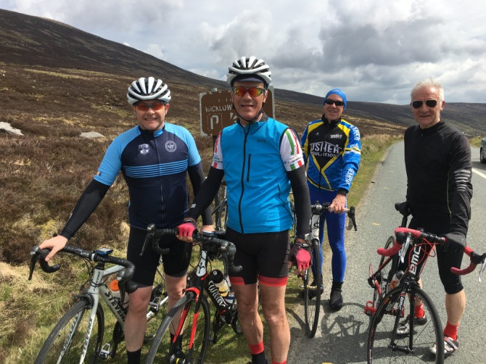
The weather conditions were good with a light wind and rising temperatures unlike other years when we cycled through the mist and fog with poor visibility to get to the top. The lead riders waited at the top of the climb as the remaining riders arrived one by one just in time for a few photos. Here we met two fellow cyclist Mick and Denis who joined the group.
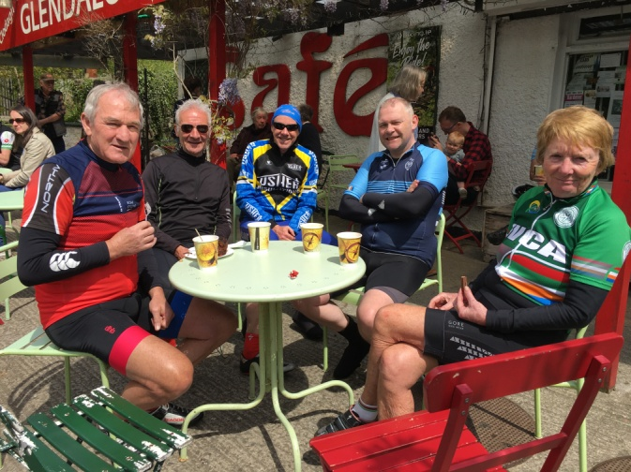
With safety in mind it was agreed to leave a time gap between each rider before commencing the 6.6M descent into Laragh. The decent was fast but controlled with a head wind in our faces with the usual passing traffic and a second Garda check point which required the riders to slow on approach.
With the sun shining and the first two climbs of the day complete all riders arrived safely in Laragh for the well earned Tea Stop. The group took time to reflect and catch up on events in cycling.
After a very enjoyable tea stop we commenced the approach to the Glenmacnass Waterfall with our two guest riders leading the way and the remainder of the group following. As the riders proceeded in the direction of the Waterfall the relatively flat terrain at the base of the climb provided riders with an opportunity to get their legs moving again. As the gradient gradually increased you could hear the sound of gears changing as riders reached for lower gears in preparation for the climb.
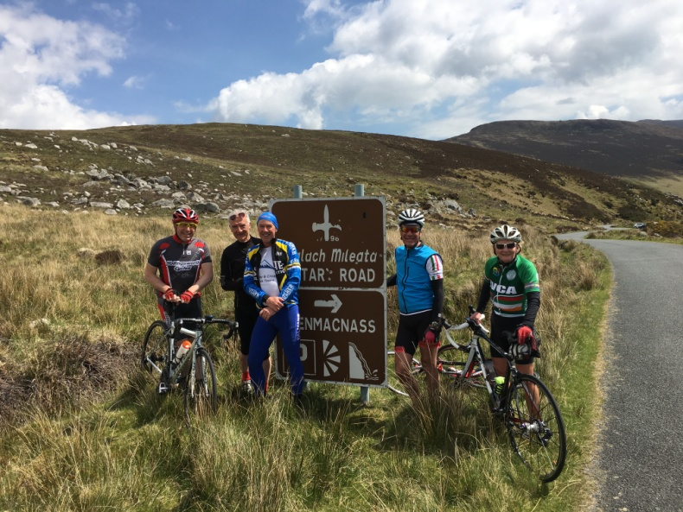
With the sun shining and no noticeable wind the climb looked inviting. As the road turned we could see the breathtaking view of the waterfall and the top of the climb was in sight.
As the riders reached the top of the waterfall we stopped to take a few photos for the record. After this short break Denis and Mick lead out at a steady pace with the remaining riders following their wheels for the 16K to the Sally Gap where Denis and Mick would leave the group for a climb to Luggala and onto Roundwood.
On arrival at the Gap we gathered and took a few more photos before commencing the decent to Manor Kilbride, mindful of the sharp turn at the bridge on the end of the decent.
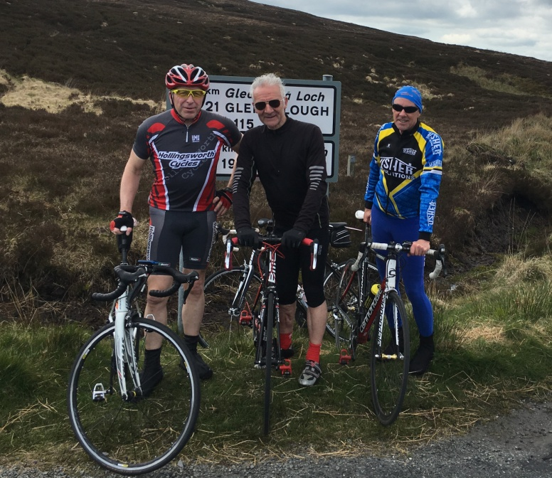
At Manor Kilbride we had time to regroup before setting out for the N81 at a steady pace. As we crossed the junction at the N81 the group singled out staying safely together heading in the direction of Brittas and on to the start of our final decent. All riders approach the decent with safety in mind and commenced the decent with a time gap between each rider making our way to the finish at Airton Road.

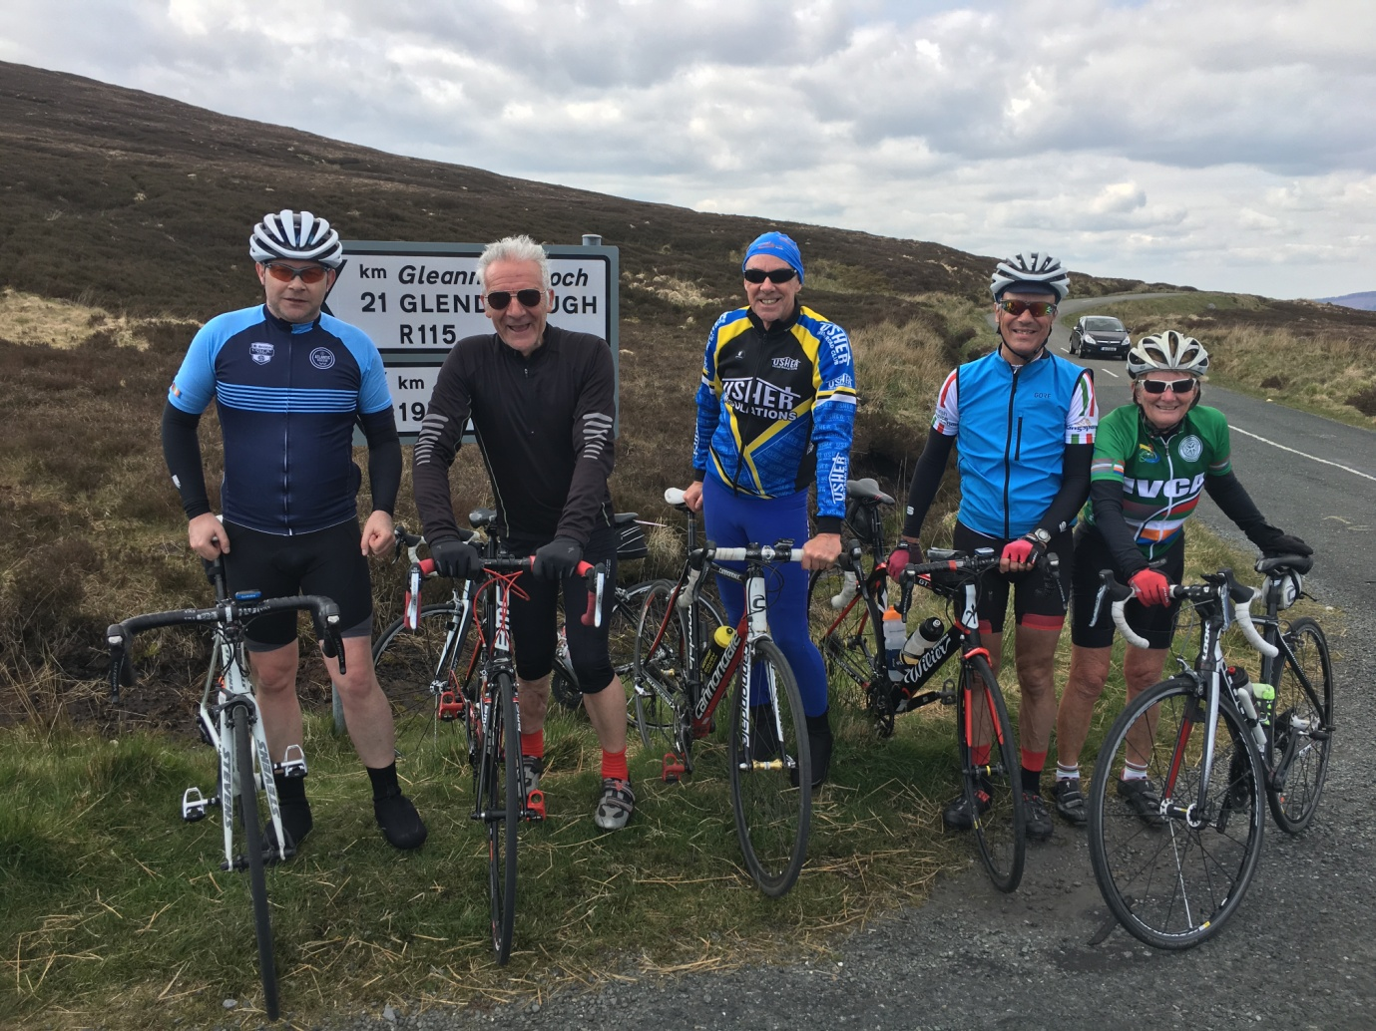
With no punctures or mechanicals all riders finished safely and in good spirits. The next event is the Wicklow 200 on the 9th June, please check the website for details.
Tony Pearson

