IVCA-Dick O Brien Leisure League 2016 Round 7 - 10th July.
The 7th round of the Leisure League commenced at 10:00 at the Papal Cross with 8 IVCA members and 1 guest showing for this mixed weather ride. Two flashy Barcelona Jerseys stood out within the group which were hard earned; well done Evelyn and Pat who also completed Malin to Mizen Head.
Before setting out, the route was discussed and it was agreed to exit the Park through the Farmleigh Gate to avoid the busy Navan Road.
The group headed out the back roads of Castleknock and onto Dunboyne, through Summerhill to Agher and return to Summerhill for the tea stop. There was plenty of chatter as usual at the tea stop with even some information on where to purchase good quality used bikes at less than half price. Well that got the interest of the group and mouths watering. (Keep an eye out for a clatter of new rides in the near future.)

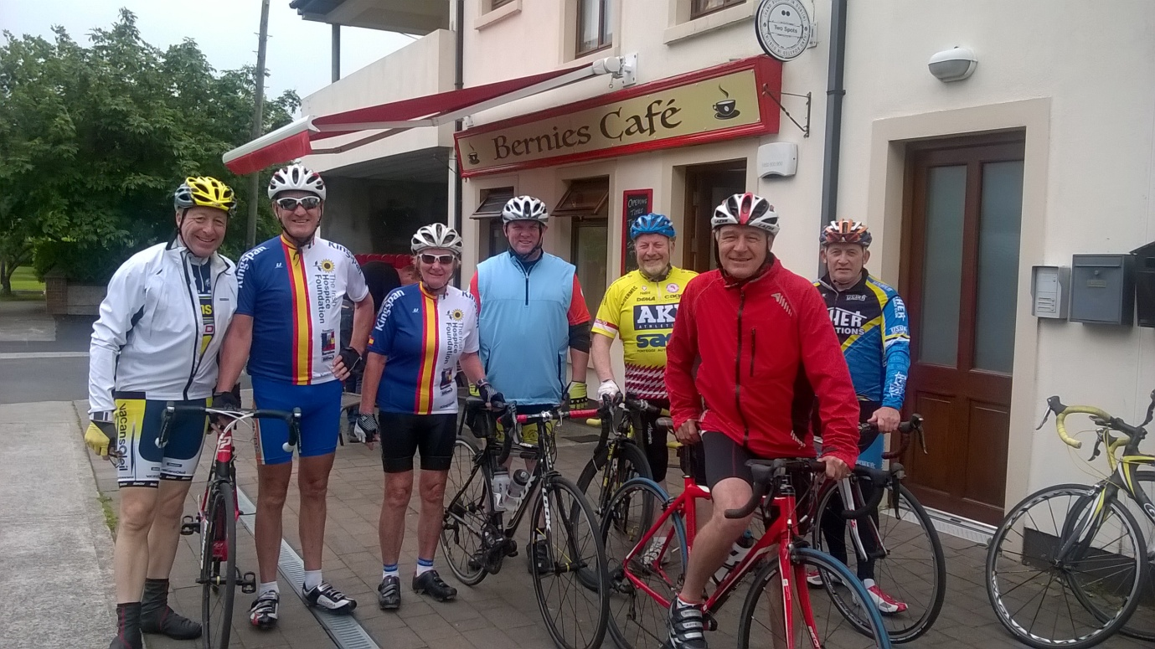
After the tea stop the group headed back to the Park with some riders breaking off in the direction of home as we approached Clonee. A good time was had by all with plenty of laughter and even a few jokes being told.
Tony Pearson.

